Subnetting Assignment

- Divide 192.168.10.0/24 into 4 Equal Subnets

To make 4 equal subnets, 2 host bits are borrowed because 2² = 4. The new prefix is /26, which gives subnet mask 255.255.255.192. Each subnet contains 64 total addresses and 62 usable host addresses.
Subnet | Subnet Mask | Network Address | Usable Host Range | Broadcast Address
1 | 255.255.255.192 (/26) | 192.168.10.0 | 192.168.10.1 - 192.168.10.62 | 192.168.10.63
2 | 255.255.255.192 (/26) | 192.168.10.64 | 192.168.10.65 - 192.168.10.126 | 192.168.10.127
3 | 255.255.255.192 (/26) | 192.168.10.128 | 192.168.10.129 - 192.168.10.190 | 192.168.10.191
4 | 255.255.255.192 (/26) | 192.168.10.192 | 192.168.10.193 - 192.168.10.254 | 192.168.10.255

- Assign Valid IP Addresses to 5 Devices

I selected Subnet 1 (192.168.10.0/26). Its valid host range is 192.168.10.1 to 192.168.10.62. The network address 192.168.10.0 and broadcast address 192.168.10.63 are not assigned to devices.
Device | Assigned IP | Subnet Mask | Default Gateway
Router | 192.168.10.1 | 255.255.255.192 | -
Laptop 1 | 192.168.10.10 | 255.255.255.192 | 192.168.10.1
Laptop 2 | 192.168.10.11 | 255.255.255.192 | 192.168.10.1
Printer | 192.168.10.12 | 255.255.255.192 | 192.168.10.1
Mobile | 192.168.10.13 | 255.255.255.192 | 192.168.10.1

- Digital Diagram of the Subnet Plan

The diagram below shows all four subnets, their usable IP ranges and broadcast addresses. The five devices are shown inside Subnet 1.
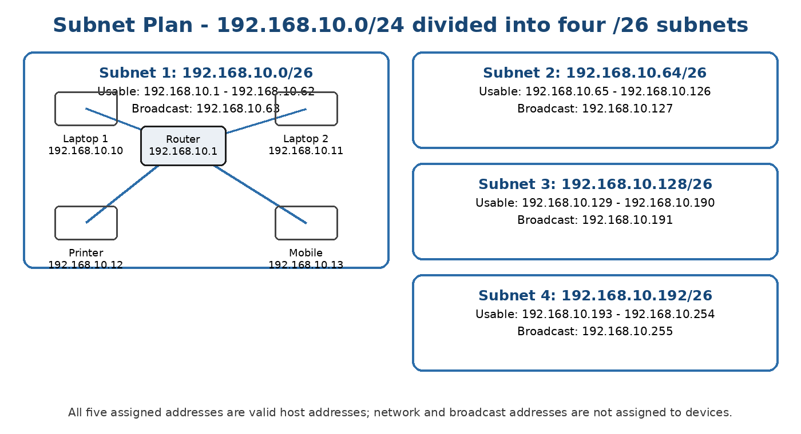
Figure 1: Subnet plan for 192.168.10.0/24
4. Step-by-Step Calculation and Explanation
1. Start with the given network: 192.168.10.0/24 has subnet mask 255.255.255.0.
2. Find how many subnet bits are needed: We need 4 subnets. 2² = 4, so we borrow 2 bits.
3. Calculate the new prefix: /24 + 2 borrowed bits = /26.
4. Find the new subnet mask: /26 = 255.255.255.192.
5. Calculate the block size: 256 - 192 = 64. Therefore, each subnet starts 64 addresses after the previous one.
6. Write the network addresses: The four network addresses are .0, .64, .128 and .192.
7. Find broadcast addresses: The broadcast is one address before the next subnet: .63, .127, .191 and .255.
8. Calculate usable hosts: A /26 leaves 6 host bits. 2⁶ = 64 total addresses. Subtract network and broadcast: 64 - 2 = 62 usable hosts.
9. Assign device IPs: Choose addresses only from the usable range. In Subnet 1, I used 192.168.10.1 for the router and .10, .11, .12 and .13 for the other devices.
Result: The 192.168.10.0/24 network was successfully divided into four equal /26 subnets. Each subnet supports 62 usable hosts, and five valid addresses from Subnet 1 were assigned without using its network or broadcast address.

